

**Spring 2020**

**CS 353 DATABASE SYSTEMS**

**TryMe**

**Group #21**

**Members:**

**Engin Deniz Kopan**

**Sarp Tekin**

**Pegah Soltani**

**Denizhan Soydaş**

**Table of Contents**

**Introduction** **2**

**Project Description** **2**

**Requirements** **3**

3.1 Functional Requirements 3

3.1.1 Applicant 3

3.1.2 Employer 3

3.1.3 Admin 4

3.2 Non-functional Requirements 4

3.2.1 Quick Response Time 4

3.2.2 User Friendliness 4

3.2.3 Privacy 4

3.2.4 Robustness 4

3.2.5 Scalability 4

3.2.6 Extensibility 5

3.3. Pseudo Requirements 5

**Limitations** **5**

**E/R Diagram** **6**

## 

## **Introduction**

HireMe is a web based platform which is intended to help developers to find a suitable job as well as the companies find the right employee for their available positions. Nowadays, there are numerous topics and expertise regarding computer science and development. Each company needs some criteria in order to hire people and mostly that criteria consists of quizzes, questionnaires and interviews. Developers have to take each company’s quiz separately which is a tedious task. HireMe is a platform that makes this task easier and more efficient for both companies and job candidates. By taking a single quiz on a certain topic the candidates can directly pass to the interview section with the company. This way, neither the developers nor the companies will waste time on generating questions and taking multiple similar quizzes.

## **Project Description**

There will be three types of users in this project consisting of Applicant, Employer and Admin. The information of each of them will be stored in our database. In the application, Applicants will be able to choose a topic that they want to work on and take a quiz regarding that topic. Admins are responsible for generating the quiz questions. Each quiz will have a comprehensive leaderboard table in which the scores, ID’s and names of the Applicant will be stored. Companies will be able to search for topics and filter the results by setting thresholds and list all of the Applicant names based on the filters.

## **Requirements**

Our requirements for the database system are divided in three main parts.

### **3.1 Functional Requirements**

Our database system for the project has three end users: Applicant, Employer and Admin. Every user should be authorized so as to use the system.

#### **3.1.1 Applicant**

* Applicants can take quizzes on multiple topics for a certain amount of times.
* Applicants can send messages to employers after taking the quizzes.
* Applicants will be able to accept or reject the job offer proposed by the employer.
* Applicants can provide their personal experience on their profiles.
* Applicants can share their personal data on their profiles.

#### **3.1.2 Employer**

* Employers can send an interview request to an applicant if they satisfy a certain criteria for the position.
* Employers should belong to exactly one company.
* Employers can filter quiz results of the applicants in terms of total score and subject of the quiz.

#### **3.1.3 Admin**

* Admins are responsible for creating quizzes.

### **3.2 Non-functional Requirements**

In our project, we have six main non-functional requirements that we will consider:

#### **3.2.1 Quick Response Time**

The users should be able to quickly see the result of their quiz. The system must respond to data requests within a reasonable amount of time.

#### **3.2.2 User Friendliness**

Any type of user should be able to easily adapt to the platform environment without having to follow an additional guide.

#### **3.2.3 Privacy**

The personal data of each user will be preserved.

#### **3.2.4 Robustness**

The system will have the ability of tolerating perturbations that might affect the system’s functional body.

#### **3.2.5 Scalability**

The platform should be scalable in terms of the growing number of users.

#### **3.2.6 Extensibility**

One of the most important aspects of this project is being up-to-date for the user experience.

### **3.3. Pseudo Requirements**

* MySQL will be the main program of our database implementation of our application. (tentative)
* We are planning to use one of these frameworks of python; flask or django. (tentative)

## **Limitations**

* The employers can search for developer candidates (applicants) by specifying the topic of their profession area and a threshold for the score they are expecting.
* Attributes such as profile picture, ethnicity and gender will not be held in our database.
* The employers will be provided with a final result after setting the filters.
* Each applicant can search for topics and take quizzes multiple times and see their results accordingly.
* Both applicants and employers can send messages to each other.
* Applicants can either accept or reject the offer proposed by a company.

## **E/R Diagram**

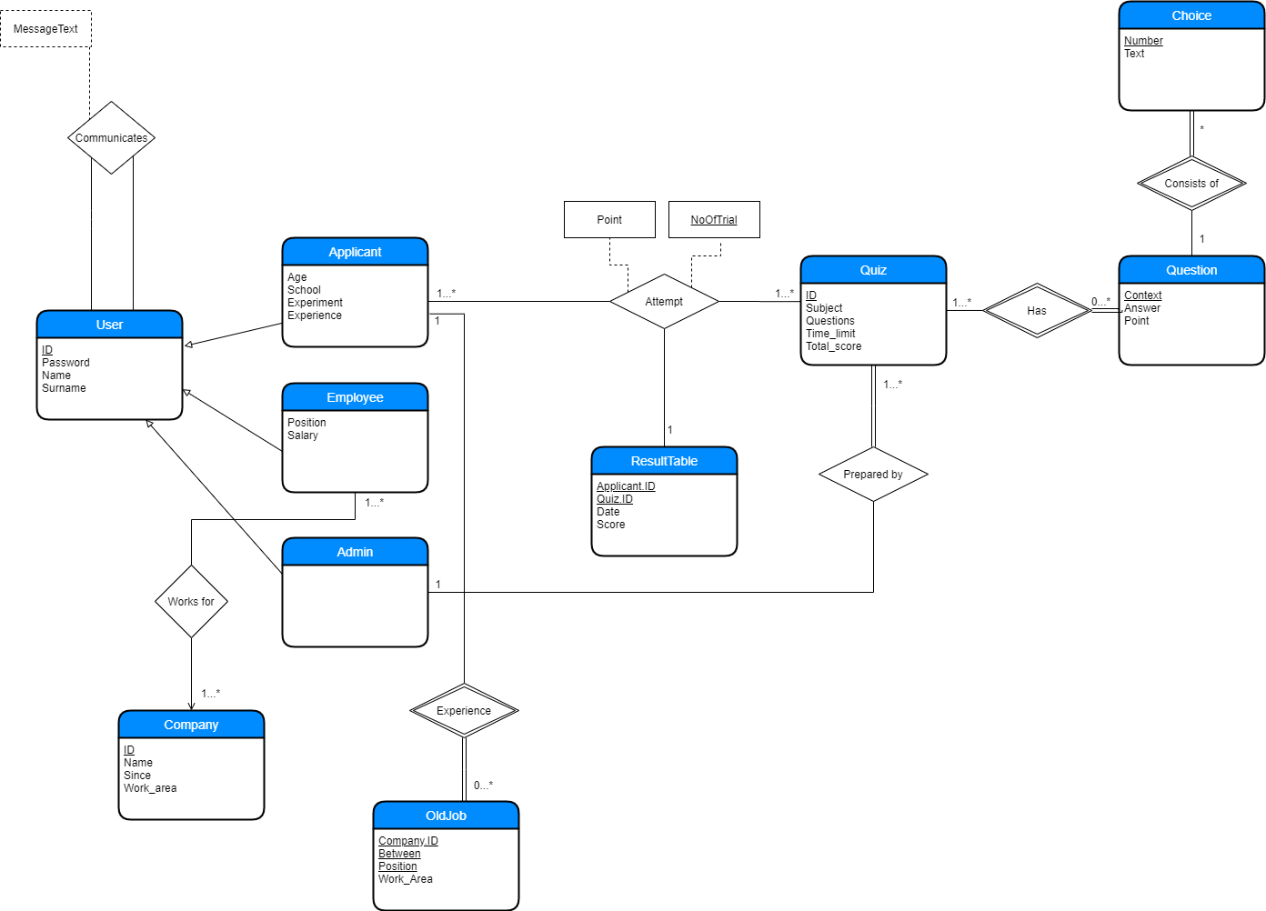

## **Conclusion**

Quiz based hiring system is a web-based application that enables employers to find a proper candidate for a specific position in the company. Employers can send quizzes which are created by admins to applicants to be solved. In this proposal, we propose a brief description of the processes of the project. Information about functional and non-functional requirements are emphasized. Limitations of the project are indicated and finally, there is an E-R diagram of the project that represents our database design.

**Project Web Site:** [**https://sarptekin.github.io/Cs-353/**](https://sarptekin.github.io/Cs-353/)